**While loop w/ end Even or Odd & Multiples**

**Submitted by: Nehemi Janvier**

**Date: 12/30/2021**

**Code:**

while True:

number = int(input("\nEnter a number to check or enter a zero to end the check: "))

if number == 0:

print ("Thank you for checking! Goodbye!")

break

if number % 2 == 0:

print ("You picked an Even Number.")

else:

print ("You picked an Odd Number.")

**Example:**

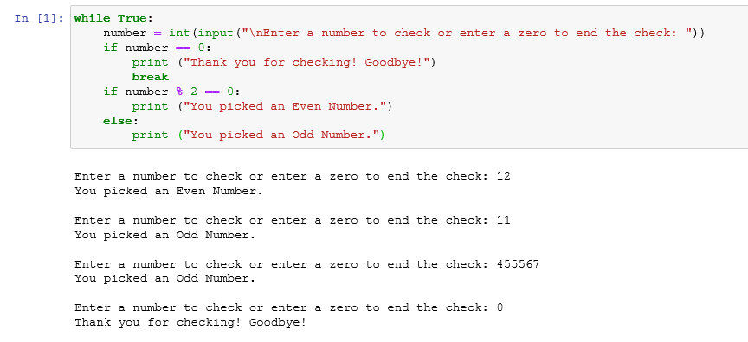

**Code:**

while True:

num = int(input("\nEnter a number to check: "))

if num % 5 == 0:

print("Thank you! " + str(num) + " is a multiple of FIVE.")

elif num % 3 == 0 and num % 2 ==0 and num % 4 == 0:

print("Thank you! " + str(num) + " is a multiple of THREE, TWO and FOUR.")

elif num % 4 == 0:

print("Thank you! " + str(num) + " is a multiple of FOUR.")

elif num % 2 == 0:

print("Thank you! " + str(num) + " is a multiple of TWO.")

else:

print("I'm not sure what " + str(num)+ " is a multiple of LOL.")

**Example:**

